CASE STUDY: Diagnosis, Investigation and Participation (DIP)

In 1991 participatory research and rural assessment methodology was introduced into the graduate curriculum of the School of Veterinary Medicine and Animal Science of the Autonomous University of the Yucatan (FMVZ-UADY), Mexico, as part of an ODA-sponsored project (DIP unpublished). The DIP group formed in 1994 as a multidisciplinary team of 10 members and decided to conduct participatory research on backyard animal production. Their objective is to improve the quality of life of indigenous communities at the forest-agriculture interface in the region through participatory innovation based on local resources.
DIP, which emerged in response to the need to fill the gap between conventional research and farmers’ needs that were not being addressed by government research and extension systems, proposes to facilitate endogenous change among small farmer families to improve food security and family well-being through the sustainable use of natural resources. Equity is sought both in terms of benefits from agricultural innovation and in the development of gender-differentiated knowledge systems. The resulting process can be divided into four overlapping, interlocking phases (Figure 1), which can be repeated as often as necessary and be constantly readjusted by the participants on the basis of new information (Gündel 1998).

Appraisal. In this phase researchers and farmers establish the common vocabulary essential for effective communication. This is accomplished by using PRA tools such as maps, calendars, ranking exercises and semi-structured interviews in order to identify the problems and potentials of the local agricultural system and to understand farmer strategies for its management. Changes that occurred within the system in the past and existing sources of information on innovations are identified. The outcome is shared information on existing local knowledge and concepts.

Convergence. In the convergence phase the actors involved negotiate and agree upon shared objectives, activities to be undertaken together, and the division of tasks and responsibilities. Negotiation does not always result in an agreement. Where there is no convergence of interests among the actors, the process is generally discontinued. In some cases, however, a partial convergence can be reached, making it possible to initiate the process. Having started the process, the participants can then re-negotiate specific objectives in subsequent cycles.
Innovation opportunities are explored and discussed among the participants. Different sources of information can be accessed, for example, from other farmer groups (as in the Farmer-to-Farmer approach), or information available from formal research. Any technology components introduced by researchers should have the potential to be modified. Group discussions and exchange visits are the principle methods used to facilitate the negotiation and decision-making. The outcome of this phase is the convergence of different objectives into a shared strategy.

Experimentation . During this phase, participants either develop new technologies or modify and adapt existing ones (external or local) to local conditions and needs. The experimentation is carried out by the participating farmers and is often organised on an individual basis. Farmers determine the experimental design. This leads to informal trials without formal requisites such as replication and control. The objective of the experimentation phase is to become familiar with the innovations being tested and adapt them to specific conditions. The researchers learn about qualitative issues such as farmers’ strategies and objectives. The management strategies for individual experiments are shared among the participants during village exchange visits, group discussions and frequent visits to each other’s plots.
The researchers’ role in this phase is to facilitate the exchange among the participants of the different ways the experiments are conducted and to provide information where required. The mechanisms used include interviews, group discussions, field visits and participant observation, combined with PRA tools. During the establishment of farmers’ experiments the researchers discuss their ideas and reasons for experiments with individual farmers and support their decisions with additional information.

Reflection. The information generated during the experimentation phase is documented, systematised and analysed by the participants. Evaluation criteria used by the farmers are identified and established and are made accessible to both farmers and researchers. Decisions on the next experimentation cycle are made based on the experiences of the previous cycle.
The role of the researchers in this phase is to facilitate the documentation, systematisation and analysis of the process. The researchers facilitate group meetings, both within the communities and between communities. Two-day workshops are often used to share experiences and to evaluate findings. Tools used during this phase include analysis of strengths, weaknesses, opportunities and threats (SWOT), preference ranking and “future visioning”.

Linking the local and formal research. DIP facilitates the flow of information between the rural communities and the FMVZ-UADY. This began once research was initiated at the FMVZ-UADY on questions identified from PRA and farmer experimentation work (Anderson in press). The sequencing of the farmer- and scientist-led research is very important: The starting point is the PRA work done within the communities. This sets the research agenda for the formal researchers and influences the way research questions are asked. The nature of the control treatments, the level of significant difference, which response variables are chosen and what level of response is sought, all depend greatly on information from the PRAs and farmer-led research process. The DIP group has made some headway in reorienting conventional research work performed at the FMVZ-UADY towards the researchable questions encountered in the community-based appraisal and experimentation phases (Anderson in press).

The DIP Group has also developed a strategy of forging partnerships with local NGOs to involve other informed actors in the identification of researchable questions. These alliances enable the NGOs to facilitate the uptake of the outputs of the participatory research by other communities where they are involved.
Based on their experiences, DIP has identified a number of lessons with respect to methodology, technology options and scaling up:

Methodological lessons
- Food security is of top priority among the very poor; thus initiatives focusing only on NRM issues will fail to achieve convergence.
- Farmers’ innovative capacity, knowledge available resources and their priorities will be heterogeneous, resulting in different economic strategies
- When there are many individuals experimenting, the pooling of their information can fulfil the function of replication.

Technological lessons
- In smallholder systems there is no one “best” practice, because farmers are always making modifications to suit their specific needs.
- Specific technologies have a life span. New technologies substitute for former ones as conditions change. This implies that farmers are involved in an ongoing search for suitable options.
- New options should be presented as modifiable components rather than as fixed and final solutions.

Scaling up
- Sufficient resources for exploiting complementarity between formal and farmer research need to be committed from the onset in order to provide continuity and follow-through on R&D priorities.
- Scaling out (i.e. starting new initiatives) may be more advantageous than scaling up (i.e. replication of a pilot-scale initiative). Small grants may be a useful mechanism for stimulating scaling out.

Figure 1. Processes associated with the DIP experience, Yucatan, Mexico. The thick arrow indicates the initiation point.

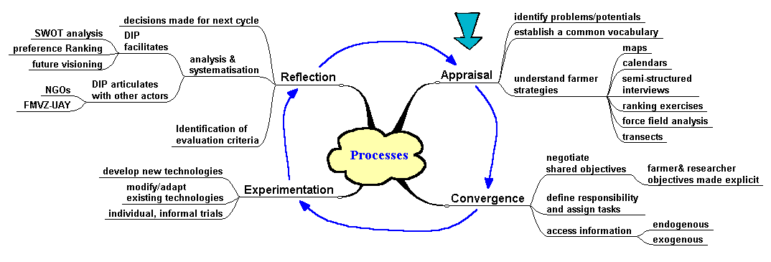
Study Questions
- What happens during the convergence phase in the DIP process? Why is convergence important?
- What are the roles of farmers and researchers? How have researchers’s changed?
- How could pooling data from many farmers serve the function of replication?

Source: Gündel, S. 1998. Participatory Innovation Development and Diffusion: Adoption and Adaption [sic] of Introduced Legumes in the Traditional Slash-and-Burn Peasant Farming System in Yucatan, Mexico, Eschborn, GTZ, 79 p.

