Case Study: Processes for accomplishing participatory research with farmers
The CIAL or farmer research committee

What is a CIAL?
- CIAL is the Spanish acronym for Comité de Investigación Agrícola Local, or "Local Agricultural Research Committee."
- A CIAL is a research service belonging to and managed by a rural community. The research team is made up of volunteer farmers, chosen because of their aptitude for experimentation. The CIAL links farmer-researchers with formal research systems, increasing local capacity to exert demand on the formal system and to access potentially useful skills, information and research products.

CIAL Principles:
- Knowledge is generated by building on experience and learning by doing
- Mutual respect and accountability and shared decision-making are the foundations of the relationship between the CIAL, the community and external actors.
- Partners in the research process share risks
- Research involves systematic comparison of alternatives.
- Research products are public goods

CIAL Processes:

 |  |  |  |  |  |  | Feedback | Training,  Site Selection  Facilitation,  Monitoring  and  Evaluation
 |  |  |  |  |  | Analysis
 |  |  |  |  | Evaluation
 |  |  |  | Experimentation
 |  |  | Planning
 |  | Diagnosis
 | Election
Motivation

Training of Facilitators and Site Selection: CIALs can be supported by research organisations, extension services or by community or farmer-based organisations. The research or extension organisations may be governmental or non-governmental. Once an organisation decides to work with the CIAL methodolgy, it needs to select and train facilitators. The training is provided by other organisations that are experienced with the CIAL methdology. Each organisation also needs needs to select the areas where the facilitators will work with CIALs. It will need to formulate criteria for selecting these areas, and revise them periodically.

Motivation: The facilitator invites everyone in the community to a meeting where the nature and purpose of a CIAL is discussed. Farmers are invited to analyze what it means to experiment with agricultural technology. Local experience in experimentation and its results are discussed. The possibility of accessing new technology from outside the community is also mentioned.

Election: If the community decides to form a CIAL, farmer researchers are chosen by the community. There are at least four members in every CIAL. A key criterion for selecting a CIAL member is that the farmer is experimenting on his/her own and is able ad willing to provide a service to the rest of the community. Each elected CIAL member has a specific role, as the leader, secretary, treasurer or communicator of the committee. The leader should be someone who is good at coordinating the work of the group. The secretary manages the information from the experiments performed by the CIAL. The Treasurer manages the financial resources of the CIAL. The Communicator communicates the results of the CIAL’s work to other farmers. CIAL members agree to serve for a minimum of one year and agree to take part in a regular training and capacity-building process. They can recruit and involve other volunteers in the research that they conduct on behalf of the community.

Diagnosis: The topic or question for experimentation is determined through a group diagnostic process in an open community meeting. The starting point is the question: “What do we want to investigate to improve our farming?” The objective of the diagnosis is to identify researchable questions of priority to the community. The prioritization of potential topics is oriented by asking questions about the likelihood of success, who and how many are likely to benefit and the estimated cost of the research.

Research
Planning: The objective of the experiments conducted by the research team is to generate information about alternative local or external technologies that are of interest to the community. The experiments are not for the purpose of demonstrating technologies or teaching ecological principles.

The facilitator helps the committee obtain the information required to plan its experiments. Other farmers and resource persons from formal research and extension systems are often consulted. The facilitator helps the CIAL formulate a clear objective for each experiment. Based on the objective, the CIAL decides what to compare, how and when to evaluate, experimental variables, criteria for evaluating results, data to be collected, and measurement units.

Experimentation: The farmer research team implements the experiment it has planned, using the CIAL fund to pay for inputs. The timing and manner of the data collection depends on the objectives of the experiment.

Evaluation: The farmer research team meets with the facilitator to evaluate the data collected. Conclusions are drawn and preparations are made to present the results to the community

Analysis: Analysis by the farmer research team includes the question “What have we learned?” This is especially important when an innovation is not successful, or when unexpected results are obtained. This ensures learning from the process as well as the results.

Scale: The CIAL pays careful attention to the scale of their experiments. The scale balances the need to minimize risk against the plot size required to obtain a meaningful result. The research process begins with a small-scale experiment (often called the exploratory trial) whose purpose is to screen out technological options that are unlikely to perform well under the local conditions. The experimental plot is kept as small as possible so that the risk of loss is minimized. If the CIAL's first experiment involves evaluating germplasm, it may include 8-10 different lines or varieties including at least one local control. The most successful treatments from the exploratory trial are planted with the local control in a slightly larger “validation” trial, which may consist of 10 rows 10 m long, for example. Finally, the best option from the validation trial is tested once more in a “production” plot. Not all research questions framed by the community may be amenable to this strategy of minimizing plot size. The exploration of management options for pest and disease problems are a good example of a research topic that may require a larger scale.

Feedback: Regular, open meetings are held in the community in which the farmer research team presents its activities, progress to date, and justifies its expenditures. This insures that their research products become public goods.

Recommendations to other farmers are based on the experiments and are explained in this meeting. Facilitators are responsible for ensuring that feedback about farmers’ research priorities and results reaches the formal research system.

Regional or national forums in which farmer research teams can exchange information and results are held annually.

Monitoring and Evaluation: The main purpose of monitoring and evaluation is to insure mutual accountability among the partners in the CIAL process. The performance of the research team is evaluated by the community and any CIAL member can be replaced.

Accountability is created by expecting the CIAL to report on the results of experiments and their use of resources in regular community meetings. Records of the experiments are kept, which belong to the community and can be shown to outsiders if desired.

The research team is required to account for its use of the CIAL fund. This ensures that their decisions about acceptable levels of risk, input levels, scale of experimentation, and when to make recommendations based on their results, are made with CIAL resources and are not distorted by subsidies or gifts from outsiders.

Representatives from the CIALs evaluate the support provided to them by their facilitators and these results shared publically.

Assuring sustainability: The conditions for sustainability are created through the establishment of the CIAL fund. This fund, which is owned by the community, helps absorb research risks. The seed money for its establishment usually comes from a one-off donation from a formal R&D organization, but may originate from a rotating fund managed by an association of CIALs. The committee uses the fund to procure inputs for experiments and to compensate members for losses. When an innovation proves successful, the CIAL may add to the fund by selling the harvest or the products of research (eg. seed). As the fund grows, the CIAL can expand its research, share earnings with participants, invest in new equipment or services, or launch a small enterprise. The community is responsible for assuring that decapitalization of the fund does not occur, and is expected to contribute to it through collective fund-raising efforts.

Facilitation: Each CIAL has four elected members and a facilitator who works with them. The facilitator may be a trained agronomist from a supportive formal research centre or university, an extension service or an NGO. Alternatively, he or she may be a trained farmer, who has served on a CIAL. The facilitator plays a key role in developing the CIAL's competence in the research process, and provides feedback on farmers’ priorities and research results to formal research and extension services.

Training, through regular visits by the facilitator, continues until the CIAL is able to manage the entire research process independently. It equips the farmer research team to conduct experiments that compare alternatives with a control treatment, and that employ replication in time and space. Training familiarises farmer-researchers with terminology that gives results credibility with formal researchers. It also builds skills in planning, management, running of meetings, monitoring and evaluation, record-keeping and basic accounting.

Facilitation of a CIAL requires profound changes in attitudes and relationships among farmers, rural communities and agricultural professionals. Training of facilitators includes a sensitisation process and learning to ask open questions that permit true two-way communication. After a two-week course, facilitators continue in-service training where they form a CIAL, supported by an experienced trainer who visits at key moments and provides feedback on strengths and weaknesses.

Facilitators are expected to respect the research priorities established by the community, and the decisions made by the farmer research team in defining experimental treatments and evaluation criteria, generating recommendations, and managing research funds.

As the CIAL becomes proficient, the facilitator reduces the frequency of visits, from two visits per month initially to one every three or four months. Facilitators visit mature CIALs for feedback on research priorities and results, and to provide access to technology under development by formal research services.

See below Table 1 describing the strengths and weaknesses of the CIAL process and Figure 1 showing how the community decides what research the CIAL will do..

Study Questions:

- What are the main steps in the CIAL process?

- What is the objective of each step?

- What are the roles of farmers and researchers?
Table 1. Strengths and weaknesses of CIALs
 | Strengths | Weaknesses
Content | Technological options are systematically evaluated by farmers in such a way that risk is minimized. | No mechanism is incorporated to develop understanding of the ecological principles which may underlying the problems being researched. Knowledge of these may be essential for the design meaningful experiments
Type of experimentation | Farmers learn basic research principles, including the function of the control and of replication; This provides for the development of a common language and two way communication with research professionals | CIALs do not learn skills for analysis of pattern and relationship;
Collection and analysis of data | Simple ranking techniques (eg. good/netural/poor) are used in analysis and and written materials are prepared to foster recordkeeping skills | Drawings of field observations for the purpose of analyzing interactions are not used
Local knowledge in gaps |  | These may be addressed through training organised by the facilitator, but offering such training is not a routine activity in the CIAL process
Scale for decision-making |  | The scale of action needed to solve a problem is not analyzed explicitly. This can be a limiting factor if the research is related to pests, diseases or other landscape-level issues
Relationship with the community |  | Depends on the cohesiveness of the community. In areas where conflicts are occurring it may be difficult to form and sustain CIALs.
Continuity | CIALs provide a permanent research service to their communities
Link to the formal research system | Strong links are developed with the formal research system, increasing the demand for prototype technologies that can be evaluated locally
Area of influence | CIALS are community-based but the radius of their influence can be increased through the formation of networks of experimenting communities and the creation of second order associations

Figure 1. The process for setting the CIAL research agenda:
This process integrates biophysical and socioeconomic concerns

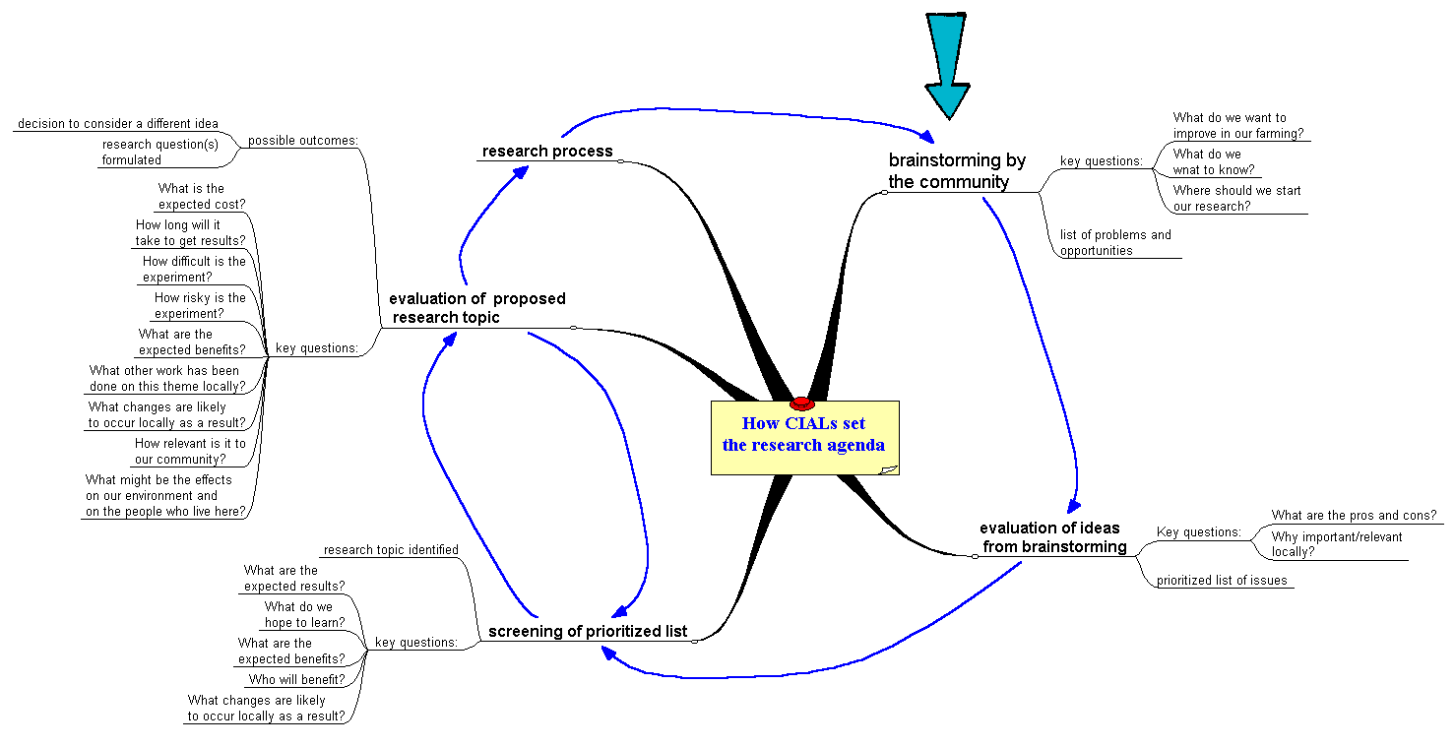

Source: Braun, A. et al. 2002. Case study annex IN: Pound, Snapp, McDougall and Braun (Eds). Uniting Science and Participation. Forthcoming book to be published by Earthscan/IDRC.

